Practical 6

Part A:
Aim:
1. Remote control: an interface Switchable with on()/off() and a default toggle(); Fan and Light implement it. Loop over a Switchable[] toggling each. Then add a functional
interface that decides, given a device and an hour, whether it may switch on, and supply it once as an anonymous class and once as a lambda.

Code:
RemoteControl.java
public class RemoteControl {

// Interface
interface Switchable {

void on();

void off();

// Default method
default void toggle() {
on();
}
}

// Fan implements Switchable
static class Fan implements Switchable {

private boolean on = false;

@Override
public void on() {
on = true;
System.out.println("Fan is ON");
}

@Override
public void off() {
on = false;
System.out.println("Fan is OFF");
}

public boolean isOn() {
return on;
}
}

// Light implements Switchable
static class Light implements Switchable {

private boolean on = false;

@Override
public void on() {
on = true;
System.out.println("Light is ON");
}

@Override
public void off() {
on = false;
System.out.println("Light is OFF");
}

public boolean isOn() {
return on;
}
}

// Functional interface
interface SwitchPolicy {

boolean maySwitchOn(Switchable device, int hour);
}

public static void main(String[] args) {

// Create devices
Switchable[] devices = {
new Fan(),
new Light()
};

System.out.println("=== Toggle Devices ===");

// Toggle every device
for (Switchable device : devices) {
device.toggle();
}

System.out.println();

// Anonymous class implementation
SwitchPolicy daytimePolicy = new SwitchPolicy() {

@Override
public boolean maySwitchOn(Switchable device, int hour) {
return hour >= 6 && hour <= 22;
}
};

// Lambda implementation
SwitchPolicy nightPolicy =
(device, hour) -> hour >= 18 && hour <= 23;

System.out.println("=== Switch Policy ===");

int hour = 20;

System.out.println(
"Anonymous class policy: "
+ daytimePolicy.maySwitchOn(devices[0], hour)
);

System.out.println(
"Lambda policy: "
+ nightPolicy.maySwitchOn(devices[1], hour)
);
}
}

Output
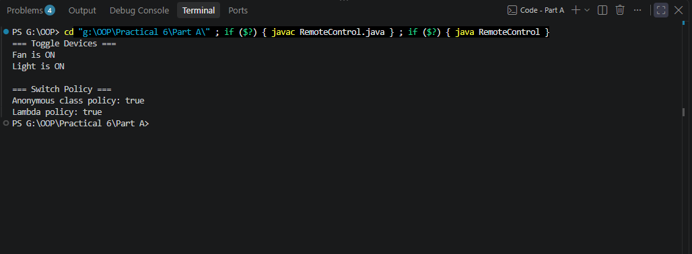

2. Notification senders: a functional interface Notifier with send(String); make email and SMS senders as lambdas, hold them in an array, and broadcast one message through all. Add a marker interface Urgent and send twice for senders marked urgent.

Code:
Notification.java
public class NotificationDemo {

// Functional interface
@FunctionalInterface
interface Notifier {
void send(String message);
}

// Marker interface
interface Urgent {
}

// Urgent email sender
static class UrgentEmail implements Notifier, Urgent {

private final Notifier sender;

UrgentEmail() {
sender = message ->
System.out.println("Email: " + message);
}

@Override
public void send(String message) {
sender.send(message);
}
}

// Normal SMS sender
static class SmsSender implements Notifier {

@Override
public void send(String message) {
System.out.println("SMS: " + message);
}
}

// Urgent SMS sender
static class UrgentSms implements Notifier, Urgent {

@Override
public void send(String message) {
System.out.println("Urgent SMS: " + message);
}
}

public static void main(String[] args) {

// Email sender using lambda
Notifier email = message ->
System.out.println("Email: " + message);

// SMS sender using lambda
Notifier sms = message ->
System.out.println("SMS: " + message);

Notifier[] senders = {
email,
sms
};

String message = "Your account has been updated.";

System.out.println("=== Normal Broadcast ===");

for (Notifier sender : senders) {
sender.send(message);
}

System.out.println();

System.out.println("=== Urgent Senders ===");

Notifier[] urgentSenders = {
new UrgentEmail(),
new UrgentSms()
};

for (Notifier sender : urgentSenders) {

if (sender instanceof Urgent) {

sender.send(message);
sender.send(message);
} else {
sender.send(message);
}
}
}
}

Output:
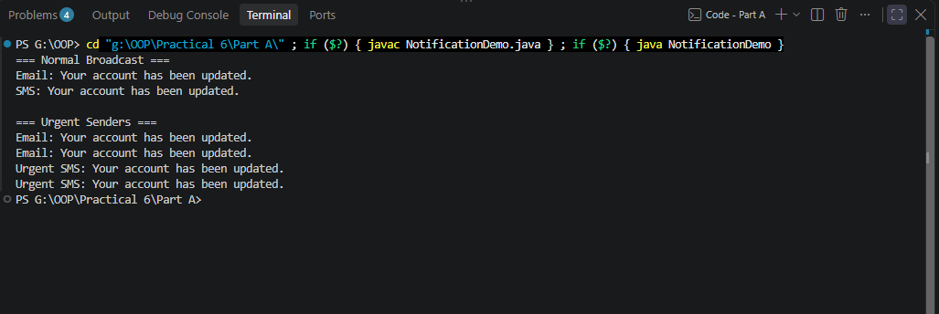

Key Questions / Analysis / Interpretation to be evaluated during/after Implementation

- What is the difference between an interface and an abstract class?

Ans.

Interface | Abstract Class
Defines a contract that classes agree to follow. | Defines a common base with shared behavior/state.
A class can implement multiple interfaces. | A class can extend only one class.
Mainly used for common capabilities/behavior. | Used when subclasses have a strong parent-child relationship.
Can contain abstract, default, and static methods. | Can contain abstract and concrete methods.
Cannot have normal instance fields representing object state in the same way as a class. | Can have instance variables and constructors.
Implemented using implements. | Extended using extends.

- What is a functional interface, and how does a lambda use it?

Ans.

A functional interface is an interface that contains exactly one abstract method.
Example:
@FunctionalInterface
interface SwitchPolicy {
boolean allowed(String device, int hour);
}
Because it has one abstract method, we can implement it using a lambda expression:
SwitchPolicy policy =
(device, hour) -> hour >= 8 && hour <= 20;
The lambda:
(device, hour) -> hour >= 8 && hour <= 20
provides the implementation of:
boolean allowed(String device, int hour);
Then:
System.out.println(policy.allowed("Fan", 10));
produces:
true

- Why is a default method useful in an interface?

Ans.
A default method allows an interface to provide a method implementation that implementing classes automatically inherit.
Example from the Remote Control practical:
interface Switchable {

void on();

void off();

default void toggle() {
System.out.println("Toggling device");
}
}
A class implementing Switchable does not have to implement toggle():
class Fan implements Switchable {

public void on() {
System.out.println("Fan ON");
}

public void off() {
System.out.println("Fan OFF");
}
}
Fan automatically gets the default toggle() implementation.

Why is this useful?
It allows developers to add new behavior to an existing interface without forcing every existing implementing class to implement the new method.

